Multi-Agent Disruption Replanning for Manufacturing Supply Chains
Project Report
Aditya Sharma (PRN 24070126016)
Amaan Saxena (PRN 24070126029)
Division A1, B.Tech Artificial Intelligence and Machine Learning
Symbiosis Institute of Technology, Pune
Code: github.com/amaansaxena/multi-agent-disruption-replanner

1. Abstract
When a supplier reports that a part will arrive late, a factory planner has to work out which customer orders will slip and how to recover, usually by hand in spreadsheets. This project builds a proof of concept in which four cooperating agents do that work. A Planner checks the alert, an Impact Analyst finds the orders that will ship late, a Replanner picks the cheapest recovery with an optimization model and drafts the supplier and customer messages, and a Critic recomputes every number from the raw data before a human planner approves or rejects the plan.
The agents are orchestrated with LangGraph, the plan is solved with PuLP, and a Streamlit app lets a person report a delay and decide. On 20 test cases on synthetic data, all 20 ended as expected, the optimized plan cost less than a manual first-come-first-served fix in all 12 cases that needed a plan (median saving 19%), and the Critic caught both planted mistakes.

2. Problem Statement
Today a planner handles a late supplier in six manual steps, and steps 2 to 6 take the most time:
- The alert arrives as an email or portal note, and someone retypes it.
- The planner traces the part through the bill of materials by hand to find affected orders.
- Stock, backup suppliers and expedite options are looked up one at a time.
- A plan is chosen, often the first workable one rather than the cheapest.
- Emails go to the supplier and customers, with numbers copied across by hand.
- If a second delay lands, the planner goes back to step 2.
Nobody double-checks the numbers before the plan goes out. The process therefore needs three things: find the cheapest recovery plan rather than the first one that works, verify the numbers independently from the raw data, and keep a person in charge of the final decision.

3. Domain and Dataset
The domain is manufacturing supply chain planning. A factory builds a few products from many parts; each part comes from one main supplier and one or two backup suppliers, and every customer order has a due date and a penalty for each day it is late. One late part holds up every product that uses it, and every order waiting on those products.
Key terms. Bill of materials (BOM): which parts go into which product, and how many. Expediting: paying extra to get a shipment faster. Backup supplier: an alternative source, usually at a higher price. Shortfall: how many units an order is missing.
All data is synthetic and generated by our own script (data/generate_data.py) with a fixed random seed (42), so every run sees the same data. No real company data or public dataset is used.
File | One row is | Notes
suppliers.csv | a supplier offering a part | 4 suppliers, 8 parts; price, lead time, capacity, main or backup
bom.csv | a part used in a product | 3 products; quantity of each part per unit
inventory.csv | stock of one part | Covers only 15 to 50% of demand; one part has no record, treated as zero
orders.csv | a customer order | 25 orders (21 open); due day 8 to 28, penalty 200 to 900 per day
scenarios.json | a test alert | 20 test cases covering normal, edge and failure situations

4. Proposed Solution
The solution splits the planner's job across four agents, each with one role and its own tools, followed by a human approval step. Numbers come from code and a solver, never from a language model.
Agent | What it does | Takes in | Hands out
Planner | Reads the alert, rejects bad ones, sets the task order, runs the retry loop and escalates when needed | Raw alert text | Disruption record and run log
Impact Analyst | Traces the late part to products and open orders, then finds the shortage and days late | Disruption record, BOM, stock, orders | Impact report per order
Replanner | Picks the cheapest recovery mix with an optimization model, runs a first-come-first-served baseline, drafts messages | Impact report, supplier options, Critic feedback | Recovery plan, total cost, baseline cost, messages
Critic | Recomputes the cost from raw data and checks the rules | Plan, messages, source data | Pass or fail, with issues

The Critic reads the raw data, not the Replanner's own totals, so a wrong number cannot vouch for itself. Figure 1 shows the full architecture and data flow.
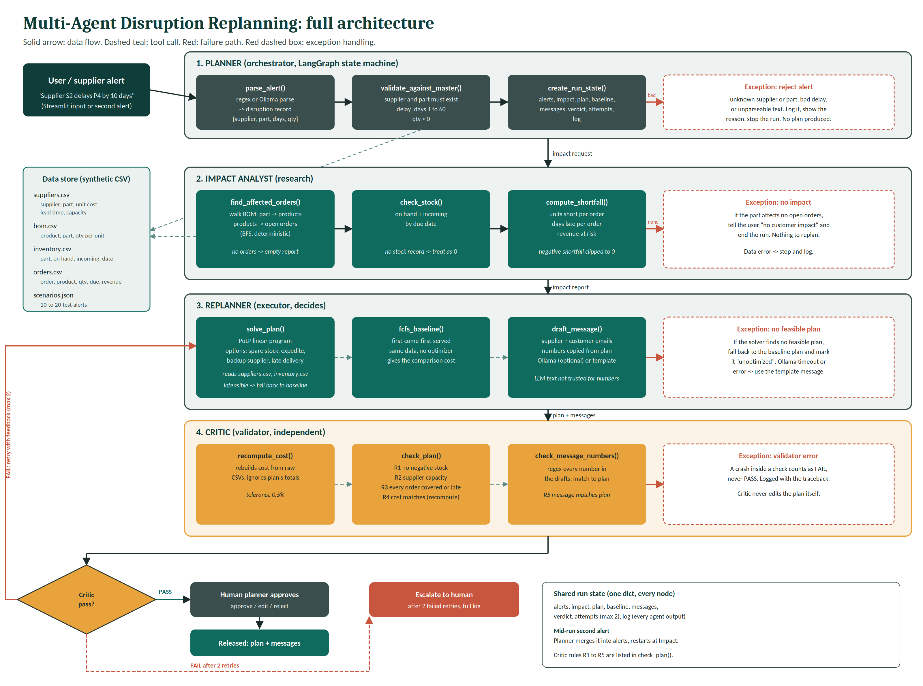
Figure 1. Full architecture: agents, their tools, the data store, failure paths and exception handling

5. Orchestration and Exception Handling
All agents share one run state (alerts, impact report, plan, baseline, messages, Critic verdict, retry count and a log). In a normal run the Planner validates the alert, then the Impact Analyst, Replanner and Critic run in order. If the Critic passes the plan it goes to the human planner. If it fails, the plan goes back to the Replanner with the Critic's feedback, up to two retries, and is then escalated to a person with the full log. If a second alert arrives mid-run, the Planner merges it and restarts at the Impact Analyst.
Situation | What happens
Bad alert | Unknown supplier or part, delay outside 1 to 60 days, or unreadable text. The run stops and says why.
No impact | The part affects no open orders, or the delay is absorbed by stock and spare time. Nothing is replanned.
Missing stock record | Treated as zero, so the shortage shows up instead of hiding.
No feasible plan | Fall back to the baseline plan and mark it unoptimized.
Critic finds a plan error | Solve again; on a second failure switch to the baseline plan.
Critic finds only a message error | Keep the plan and redraft only the messages.
Human rejects the plan | Offer the baseline plan instead; a second rejection goes to a person.
Critic check crashes | Counts as a fail, never a pass.

Critic rules
- R1 No negative stock: the plan never uses more stock than is on hand.
- R2 Supplier quantities stay within capacity, and every source in the plan really exists.
- R3 Every affected order is fully covered, or listed as late with its delay.
- R4 The recomputed cost matches the reported cost within a small tolerance.
- R5 Every number in every message matches the plan.

6. Optimization Model
For each affected order, the Replanner decides how many units to take from each source. The four sources are stock on hand (free, available now), waiting for the late shipment (list price, arrives late), rushing the late supplier (35% more, half the delay, limited to half its capacity) and buying from a backup supplier (10% more, its own lead time and capacity).
This is a mixed-integer linear program solved with PuLP and the CBC solver. Unit counts are whole numbers, and a yes/no variable records whether an order uses any source that arrives after its due date, because one late unit makes the whole order late. The objective minimizes parts cost plus late penalties, subject to every order being fully covered, each source's capacity, and the rushed and waited units together not exceeding what is in transit.
The comparison point is a first-come-first-served baseline, our stand-in for a busy planner: go through orders by due date, use stock first, then take the first rush or backup supplier that covers the whole remaining amount in time, otherwise wait. It is also the fallback whenever the optimized plan cannot be used.

7. Implementation
Component | Technology and role
Agent workflow | LangGraph state graph: nodes for each agent, conditional edges for pass, fail, retry, reject and escalate
Optimization | PuLP with the CBC solver
Data handling | pandas, reading four CSV files
User interface | Streamlit app: report a delay, see the plan, approve or reject
Alerts and messages | Rule-based alert reading and template messages, so no number depends on a language model
Testing | Tool tests, agent-path tests, app click-through tests and a 20-case scenario runner

In the app the user picks the late supplier, the part and how many days late it is, or runs a ready-made example. Figure 2 shows a plan waiting for approval: 5 orders would ship late with 18,350 in penalties if nobody acts, and the plan costs 9,363, 15% less than the manual fix. Nothing is sent until the user presses Approve; rejecting offers the manual fix instead.
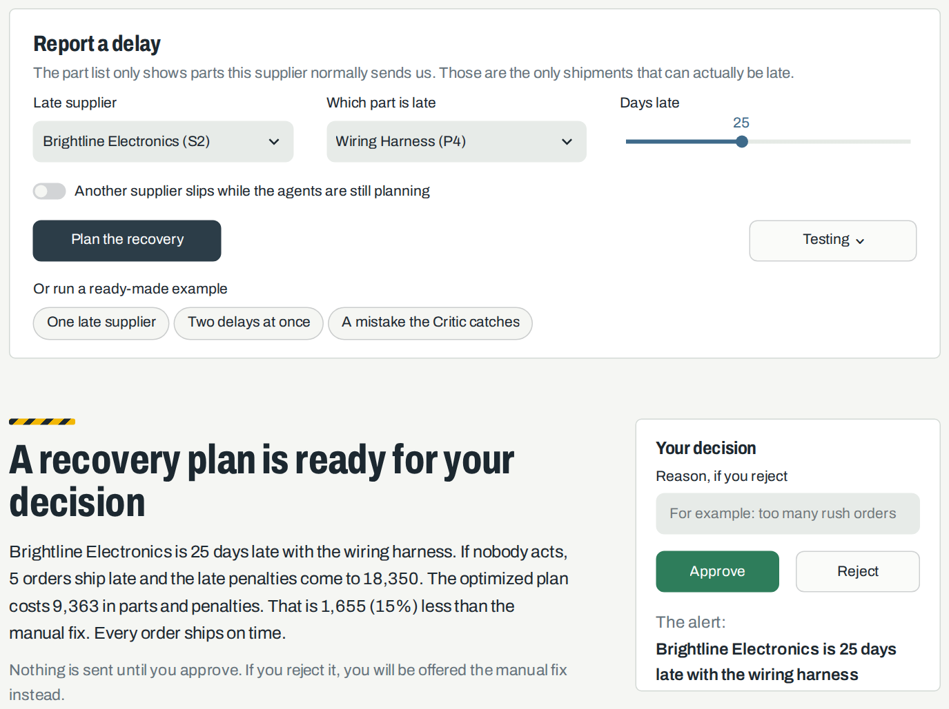
Figure 2. Reporting a delay and deciding on the recovery plan
Figure 3 shows every affected order day by day for two delays at once. Each row is a customer order: the grey line runs to its due day and the dot marks when it ships, green if on time and red if late. The striped bars are the late shipments, moved from their old arrival day to the new one.
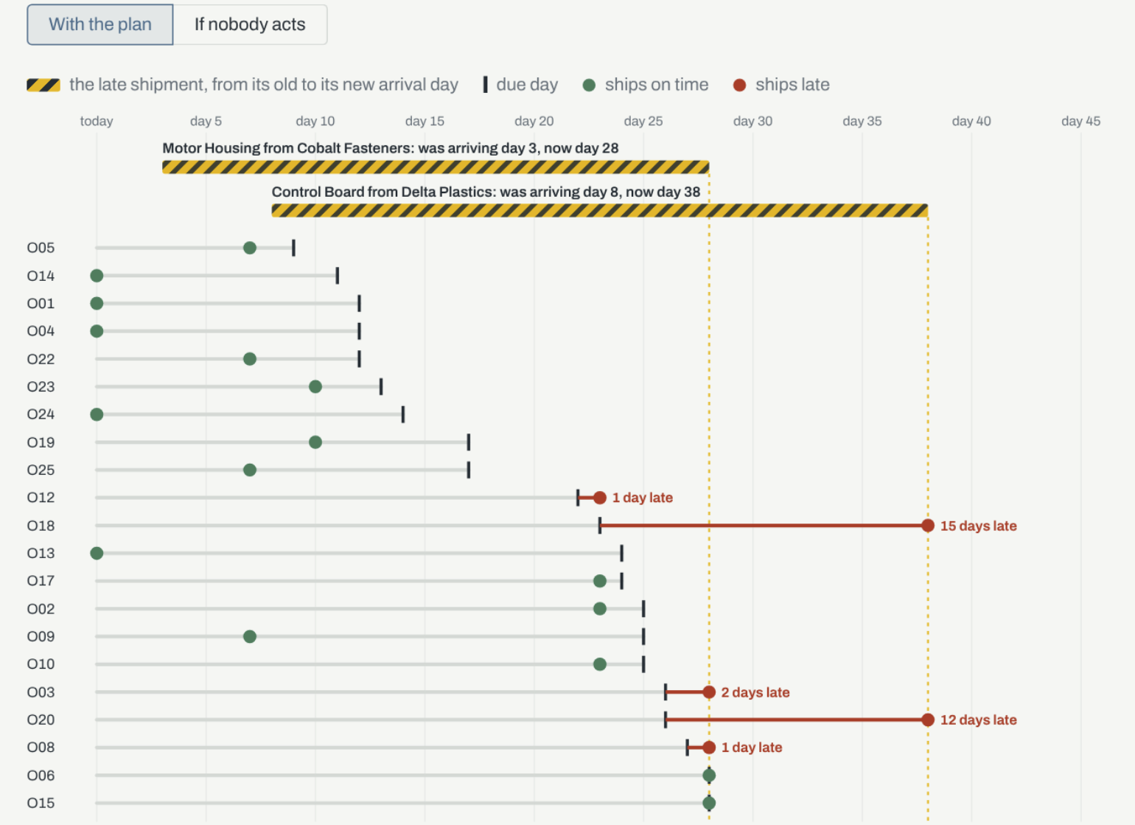
Figure 3. Every affected order, day by day, with two delays at once
To prove the Critic works, a mistake can be planted on purpose. When supplier messages always quote one unit too many, the Critic finds 363 where the plan says 362, sends the plan back, fails the rewritten messages again, and after three failures in a row hands the case to a person (Figure 4).
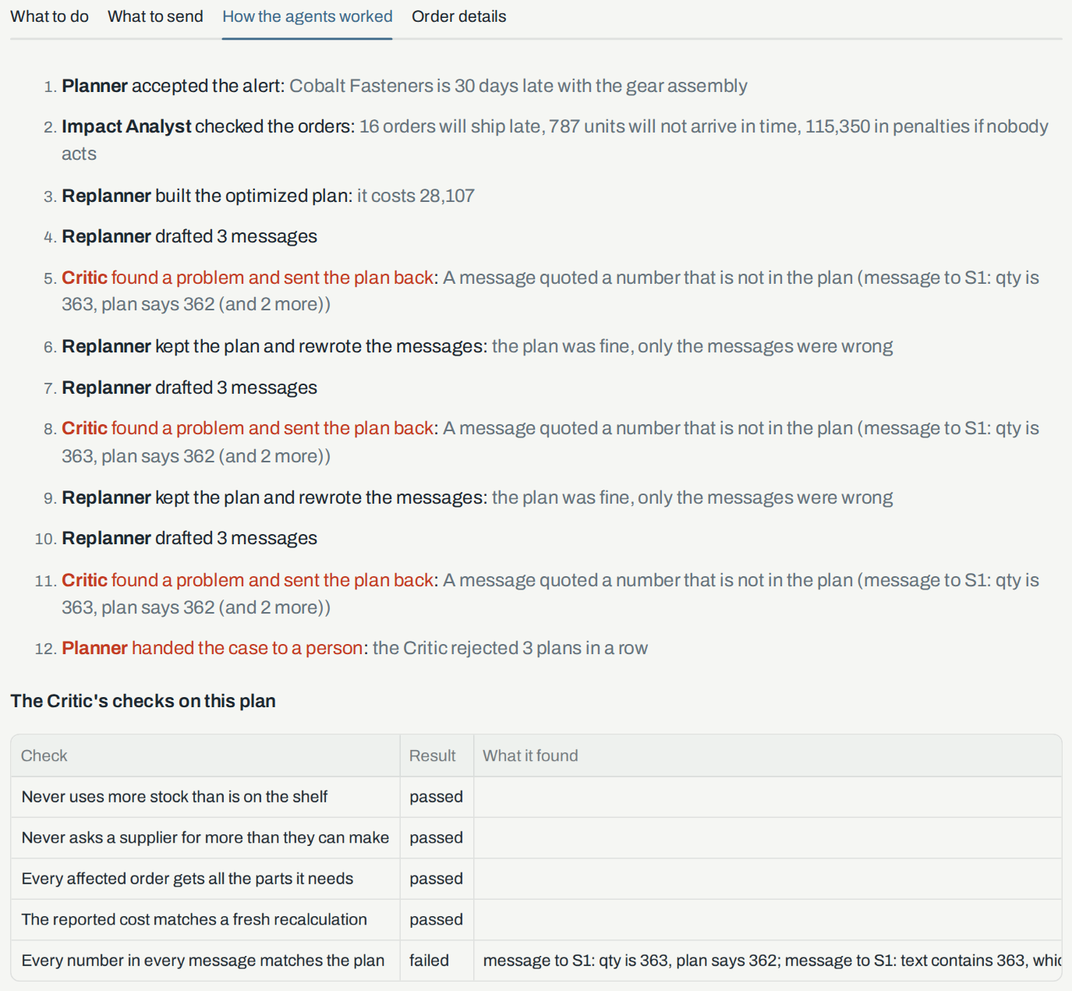
Figure 4. The Critic catches a planted mistake and escalates to a person

8. Results and Validation
Result | Meaning
20 of 20 | test cases end the way they should
12 of 12 | replans cost less than the manual fix
19% | median saving, ranging from 5% to 80% across cases
2 of 2 | planted mistakes caught by the Critic

Cost is parts plus late penalties. Across the 12 replans the optimized plan had 21 late orders against 22 for the manual fix, but in two cases it had more, because a small penalty can cost less than a rush. Figure 5 shows one such case: the plan leaves 5 orders late against 2 for the manual fix, yet costs 8,193 less.
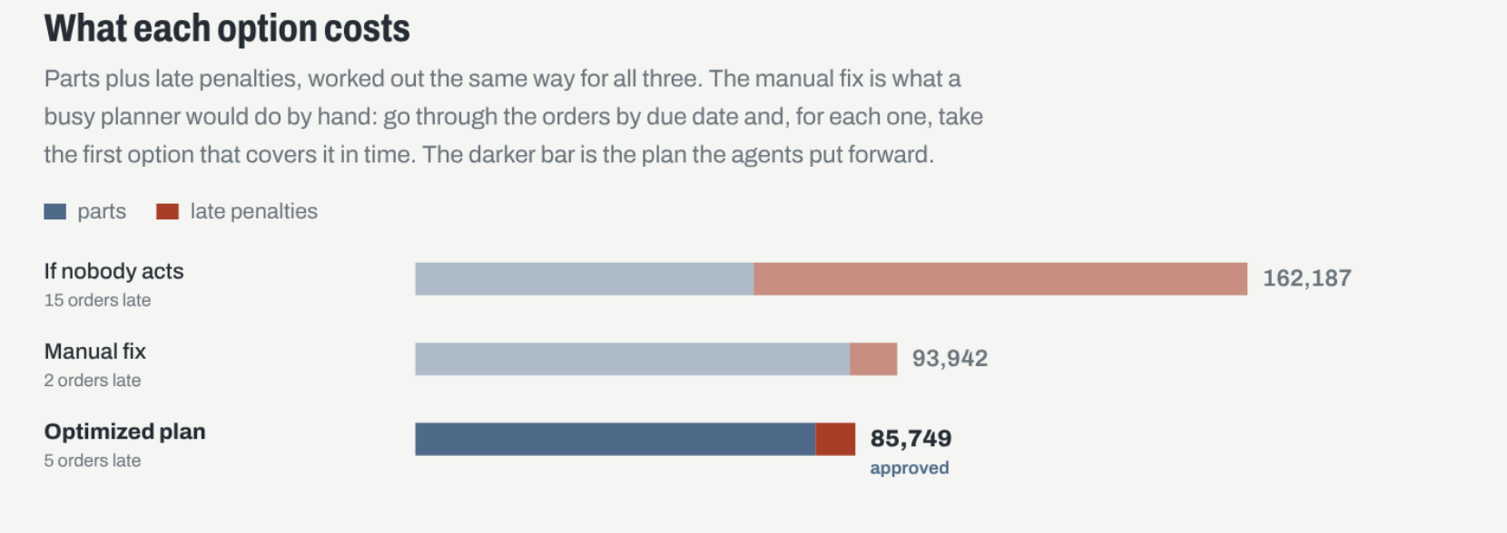
Figure 5. Cost of each option for two delays at once
The median is quoted rather than the total, because two long-delay cases save about 80% and would inflate an overall figure. The manual fix is our own stand-in for a busy planner and the data is synthetic, so these results show that the workflow works, not what a real plant would save.

9. Limitations and Future Work

Known limitations
- The supply chain is small and synthetic, so the results show the workflow, not real savings.
- Costs are modelled linearly, with no uncertainty in how long a delay will last.
- The Critic's rules were written alongside the test cases, so real-world performance would likely be lower.
- Alerts are read with simple rules and messages are templates; this version has no language model in it.

Future work
- Add constraints such as production capacity and multi-tier suppliers.
- Connect real ERP data through connectors.
- Feed supplier replies back into the plan.
- Use a language model to read free-text alerts and draft messages, with the Critic still checking every number.

10. Conclusion
The project shows that a late-supplier problem can be split into clear agent roles: checking the alert, measuring the impact, optimizing the recovery and independently verifying it, with a person making the final call. Separating the doing from the checking caught every planted error, the optimizer beat a realistic manual baseline in every replan, and the system escalates to a person instead of guessing when it cannot produce a plan it trusts.

References
- LangGraph documentation, LangChain. https://langchain-ai.github.io/langgraph/
- PuLP: a linear programming toolkit for Python. https://coin-or.github.io/pulp/
- Streamlit documentation. https://docs.streamlit.io/
- Project repository. https://github.com/amaansaxena/multi-agent-disruption-replanner

